Teaching English Through Difficult Textbooks: (English title in Century Bold, 12 point)
The Integration of Round System (If not, make one line space)
難しい高校教科書を用いた英語で行う授業の実践 (Japanese title in MS P Mincho Bold, 12 point)
―ラウンド制指導法の融合― (If not, make one line space)
Keywords： keyword 1, keyword 2, keyword 3 (Century 10.5point)

Space between the family/given name in English/Japanese→CHUBU Taro (Century, 10.5 point)
中部 太郎 (MS P Mincho, 10.5 point)
1. Introduction （Century Bold, 10.5 point）←The main text begins on the ninth line
Follow this template (Century 10.5 point for text, affiliation at the time of submission, notes, and references).

1.2 Section Number
Heading numbers are followed by a period. Citation brackets are written in half-width (), as in (Shirahata, 1988; Swain, 1995, p. 127).

2. Table and Figure
Tables are numbered consecutively. The serial number and the title of the table are on the same line, with one line space at the top and bottom of the table. Numbers and letters are aligned. No borders as in the sample.

Table 1 Descriptive Statistics
Group | Test | M | SD | Skewness | Kurtosis | Min | Max
Treatment  (n = 33) | Pre-Test | 2.91 | 2.09 | 1.07 | 1.16 | 1.03 | 9.10
 | Post-Test | 4.32 | 2.23 | 0.16 | 1.34 | 1.23 | 8.64
Contrast  (n = 33) | Pre-Test | 3.32 | 2.44 | 0.23 | 1.31 | 1.12 | 8.82
 | Post-Test | 3.82 | 2.42 | 0.20 | 0.97 | 1.54 | 8.89

Figures are numbered consecutively. The serial number and the title of the figure are on the same line, with one line space at the top and bottom of the figure. No colored figures (including photographs, etc.), as in the sample.

Figure 1 Box Plots with Individual Data Points
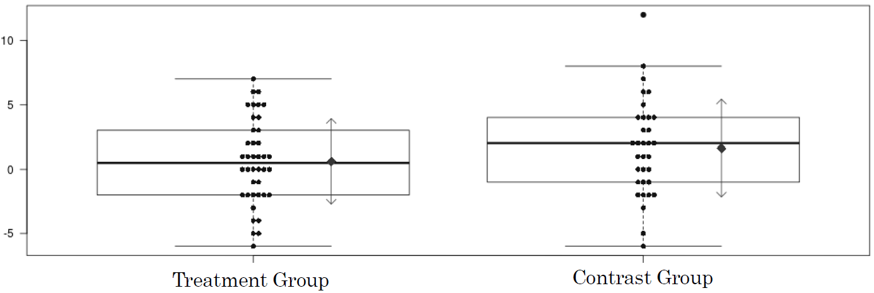

References
Cook, V. (1991). Second language learning and language teaching. Edward Arnold.
Gass, S. M. (1997). Input, interaction, and the second language learner. Lawrence Erlbaum.
Lightbown, P. M., & Spada, N. (1999). How languages are learned (2nd ed.). Oxford University Press.
Nassaji, H. (2003). L2 vocabulary learning from context: Strategies, knowledge sources, and their relationship with success in L2 lexical inferencing. TESOL Quarterly, 37(4), 645–670. https://doi.org/10.2307/3588216
Shirahata, T. (1988). The learning of English grammatical morphemes by Japanese high school students [Master’s thesis, The University of Arizona]. The University of Arizona Campus Repository. https://repository.arizona.edu/handle/10150/276802
Swain, M. (1995). Three functions of output in second language learning. In G. Cook & B. Seidlhofer (Eds.), Principle & practice in applied linguistics: Studies in honour of H. G. Widdowson (pp. 125–144). Oxford University Press.

